Programming Fundamentals Lab

Lab Assignment 03

Course Code: CL1002

Syed Muhammad Shuja Ur Rahman

Roll No. 22K-4456

Ms. Ayesha Ali

**QUESTION#1** Write the datatypes of the following values:

• “Introduction to IDE and basic programing constructs”

string

• 3x108

float

• 300000000

integer

• 7.0000000000005

Double

**QUESTION#2** Explain the output of this C program. Why the wrong value is being displayed in the output?

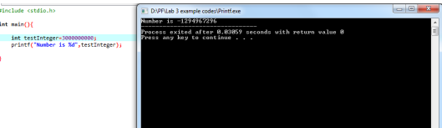

The value stored in the variable **‘test integer’** exceeds the limit of storage of ‘**int**’ data type

**QUESTION#3** Write a C program that takes two integer values as input from the user. Then swap the values taken from the user and display the output of the variables.

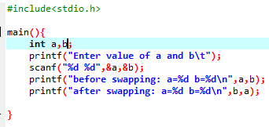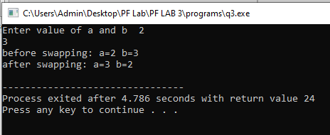

**QUESTION#4** A customer asks the IT firm to develop a program in C language, which can take tax rate and salary from the user on runtime and then calculate the tax, the user has to pay and the salary he/she will have after paying the tax. This information is then provided to the user.

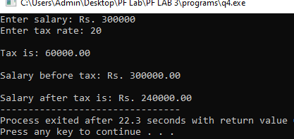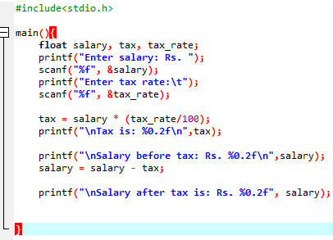

**QUESTION#5** A car traveled for some hours. The time car traveled is taken at run time of the program, and it must not be negative and must be between one to five hours. The car had not traveled same distance in each hour. The distance that the car covered must not be negative. Write a C Program that computes the Average Speed of the Car in miles per hour. Hint: the restrictions can be displayed in the form of message on the window.

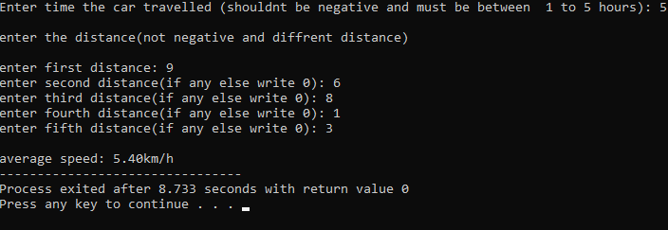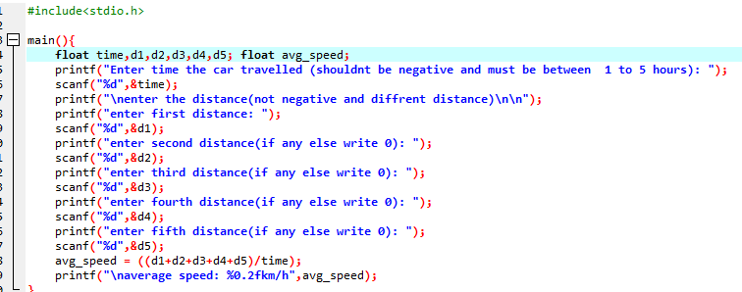

**QUESTION#6** Write a C Program to format an integer number, the integer number occupies a minimum number of 9 spaces on the screen.

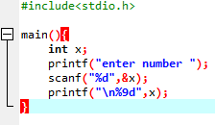

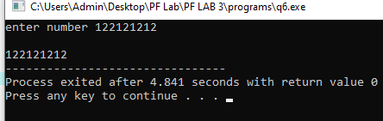

**QUESTION#7** Construct a C program with the flowchart below. The input value of the Principle must be between Rs. 100 To Rs. 1,000,000. The Rate of interest must be between 5% to 10% and Time Period must be between 1 to 10 years. Hint: these restrictions can be displayed in the form of message on the window.

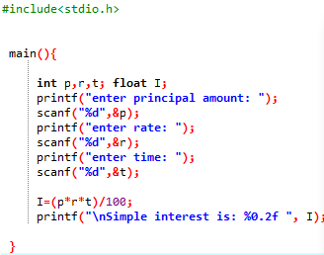

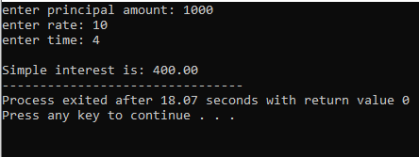

**QUESTION#8** Write a C Program to play beep five times.

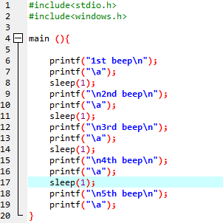

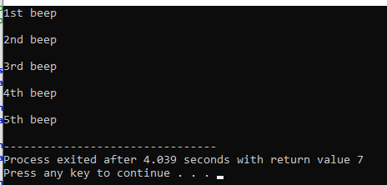

**QUESTION#9** Write a C program to print the following shapes using escape sequences. Moreover, you are required to compile and execute these program using CMD.

